

**KHULNA UNIVERSITY OF ENGINEERING & TECHNOLOGY, KUET**

***Department of Electronics & Communication Engineering, ECE***

**Course No: ECE 3200**

**Course Name: Electronics Project Design/Development**

**Project Name:**

**Web Controlled Surveillance Robot with Object sensing by Arduino Uno.**

Submitted By:

Name: Simina Manna Trisha Name: Auhona Islam

Roll No: 1709043 Roll No: 1709049

Dept. of Electronics and Communication Dept. of Electronics and

Engineering, KUET Communication Engineering, KUET

Supervised By:

Dr. Pallab Kumar Chowdhury

Professor, Department of ECE,

Khulna University of Engineering & Technology

Submission Date: 28th February, 2022

**Overview:**

Security is a major thing to focus on during this modern era as it is very important to secure your surroundings for the wellbeing of oneself and his family. But there are many drawbacks of using conventional security surveillance cameras as they have to be set in a particular angle for good visual and they do not cover a large area, conventional security cameras can only be used from a particular device and cannot alert the user during an unforeseen circumstance. Hence, we require a much more efficient device for better security a web controlled surveillance robot is much more practical device to be used compared to conventional security surveillance, this system needs a single camera to perform its operation and the user can monitor a wide range of area, any device with a wireless connection to the internet can be used to operate this device. This robot can move to any location within the range of the network and can be accessed globally from anywhere and as it uses only one camera to secure a large area it is also cost-efficient. At the core of the system lies Arduino Uno which is responsible for all the operation of the system and the size of the device can be engineered according to the area it is to be used.

**Objectives:**

The basic aim behind the proposed concept is to build a standalone device that will be a viable alternative to the conventional surveillance security system. Such a system should be easy to use, reliable, and affordable. The system will operate by using sensors to collect the data, which will be sent to a microcontroller which will a control a robot’s behavior.

The objective of this project is to design a prototype surveillance system that will require minimal installation, while offering more comprehensive monitoring. It will be more complete and user friendly than most of the surveillance systems presently on the market. Home monitoring will be realized by a standalone robotic unit. This robot will provide monitoring for a huge time and interact with its user by transmitting real-time video footage and text data. If the robot can sense any anomalies it will give the user an alert message.

**Required Components:**

* Arduino UNo
* ESP32 Camera
* L293D Motor Driver Module
* DC Motors
* Ultrasonic Sensor

**Circuit Diagram:**

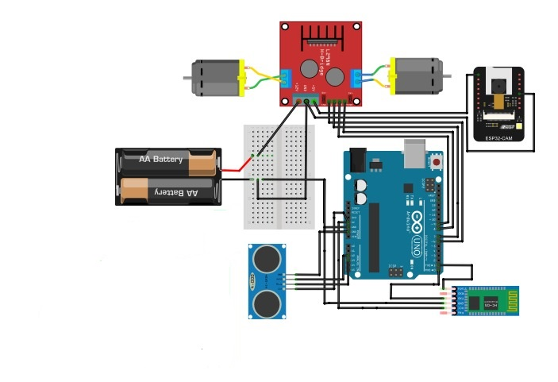

Fig-1: Circuit diagram for Web Controlled Surveillance Robot with object sensing by Arduino UNO.

**Component feature:**

**Arduino UNO:**

The Arduino UNO is a popular microcontroller board based on the ATmega328P microcontroller, which operates at 16 MHz. It has 14 digital I/O pins (6 of which support PWM), 6 analog input pins, and a variety of power supply options, including 5V and 3.3V outputs, as well as a VIN connector for external power.  
The board has a USB port for programming and serial communication, a power jack for external power sources, and a reset button to restart the microcontroller. The ICSP header enables direct programming of the microcontroller, while the AREF pin offers an external reference voltage for analog inputs. The built-in LEDs indicate power and data transfer, and an on-board LED attached to digital pin 13 allows for testing.  
The Arduino UNO supports several communication interfaces, including SPI (digital pins 10-13), I2C (A4, A5), and UART (digital pins 0, 1). A voltage regulator ensures a consistent power supply from external sources, making the Arduino UNO an adaptable platform for a variety of electronic projects.

**ESP32 Camera:**

The ESP32-CAM is a low-cost development board with an integrated camera and microprocessor that uses the ESP32-S microcontroller chip. It has a strong dual-core processor running at 240 MHz, 520 KB of SRAM, and includes Wi-Fi and Bluetooth connectivity, making it suitable for IoT applications.  
The OV2640 camera module, which can capture photos at resolutions of up to 1600x1200 pixels as well as video at lesser levels, is a key component. The board includes a microSD card port for storage expansion, which can be used to save photographs or record data. It also has a built-in flash LED, which may be utilized as a camera flash or for general lighting.  
The ESP32-CAM includes several GPIO pins for connecting to external sensors, actuators, and other devices, and it supports a variety of communication protocols including as SPI, I2C, and UART. The board lacks a USB port, therefore programming requires an additional USB-to-TTL serial converter.  
Power can be supplied via the 5V pin or directly through the 3.3V pin. The board also has a reset button and an on-board antenna for wireless connection, with the option of connecting an external antenna for greater range.  
Because of its tiny size, camera integration, and wireless capabilities, the ESP32-CAM is widely utilized in surveillance, IoT, and AI-based image recognition applications.

**L293D Motor Driver Module:**

The L293D is a dual-channel H-Bridge motor driver capable of driving a pair of DC motors or single stepper motor.

As the shield comes with two L293D motor driver chipsets, that means it can individually drive up to four DC motors making it ideal for building four-wheel robot platforms. The shield offers total 4 H-Bridges and each H-bridge can deliver up to 0.6A to the motor.

**DC Motors:**

A DC motor functions by obtaining electrical supply from the battery. For heavy weight stronger motors are required. Many parameters should be taken into consideration while choosing an electric motor. There are various types of motor used for robots. Based on the application, motor should be used. DC Motors provide high torque and high efficiency. DC motors are used for wheeled because of its simple design. The wheels can be easily connected to DC motors. The Most commonly used electric motors in wheeled robots are the DC motors. By applying torque in response to load, the DC motors are often characterized by the speed and torque curve. Voltage ratings commonly preferred for DC motors used in robots are 3, 6, 12 and 24 Volts. Lower voltage should not be given to the DC motor, it may cause damage to DC motors. If a higher voltage is applied to the motor, it may get heat up and can get damaged. A heavier robot requires stronger motors.

**Ultra Sonic Sensor:**

An ultrasonic sensor is a device that detects distance by producing ultrasonic sound waves and then measuring how long it takes for the echo to return after bouncing off an object. It is made up of a transmitter that sends out sound waves, a receiver that detects the echo, and a control circuit that calculates the distance depending on the time delay.  
The sensor emits a sound pulse that reflects off an object and returns to the receiver. The sensor then estimates the distance to the item based on the time it takes for the echo to return.  
The HC-SR04 is a popular ultrasonic sensor with a range of 2 cm to 4 meters and an accuracy of approximately 3 mm. It runs at 5 volts and measures distance using digital pulses.  
Ultrasonic sensors are used in robotics to identify obstacles, in vehicles to assist with parking, and in industry to assess tank levels.  
Ultrasonic sensors are prized for their dependability in a variety of settings, including those where optical sensors may fail, such as in the presence of dust or smoke.

**Working Procedure:**

Firstly we have interfaced the ESP32 camera with Arduino UNO. Then , we have worked for video feed through motion software. Motion software can monitor video from the camera and it can detect any change in the picture. The Arduino UNO software code have passed to the hardware device and the ultrasonic sensor attached there can sense any movement of any object and the robot moves if it finds anything unusual.

**Application:**

1.Wi-Fi based wireless broadband services could be used for public surveillance systems.

2. Wireless surveillance cameras can be useful in situations where it is difficult to lay cables – Museums, Heritage, Buildings, Industrial plants, etc.

3. This surveillance system is cost effective (when compared to wired networks involving Fiber Cables, Trenching, etc.) to install and maintain.

4. Wireless Networks can be deployed quickly and wireless surveillance can be used for providing temporary Wi-Fi to fairs/ exhibitions, etc.